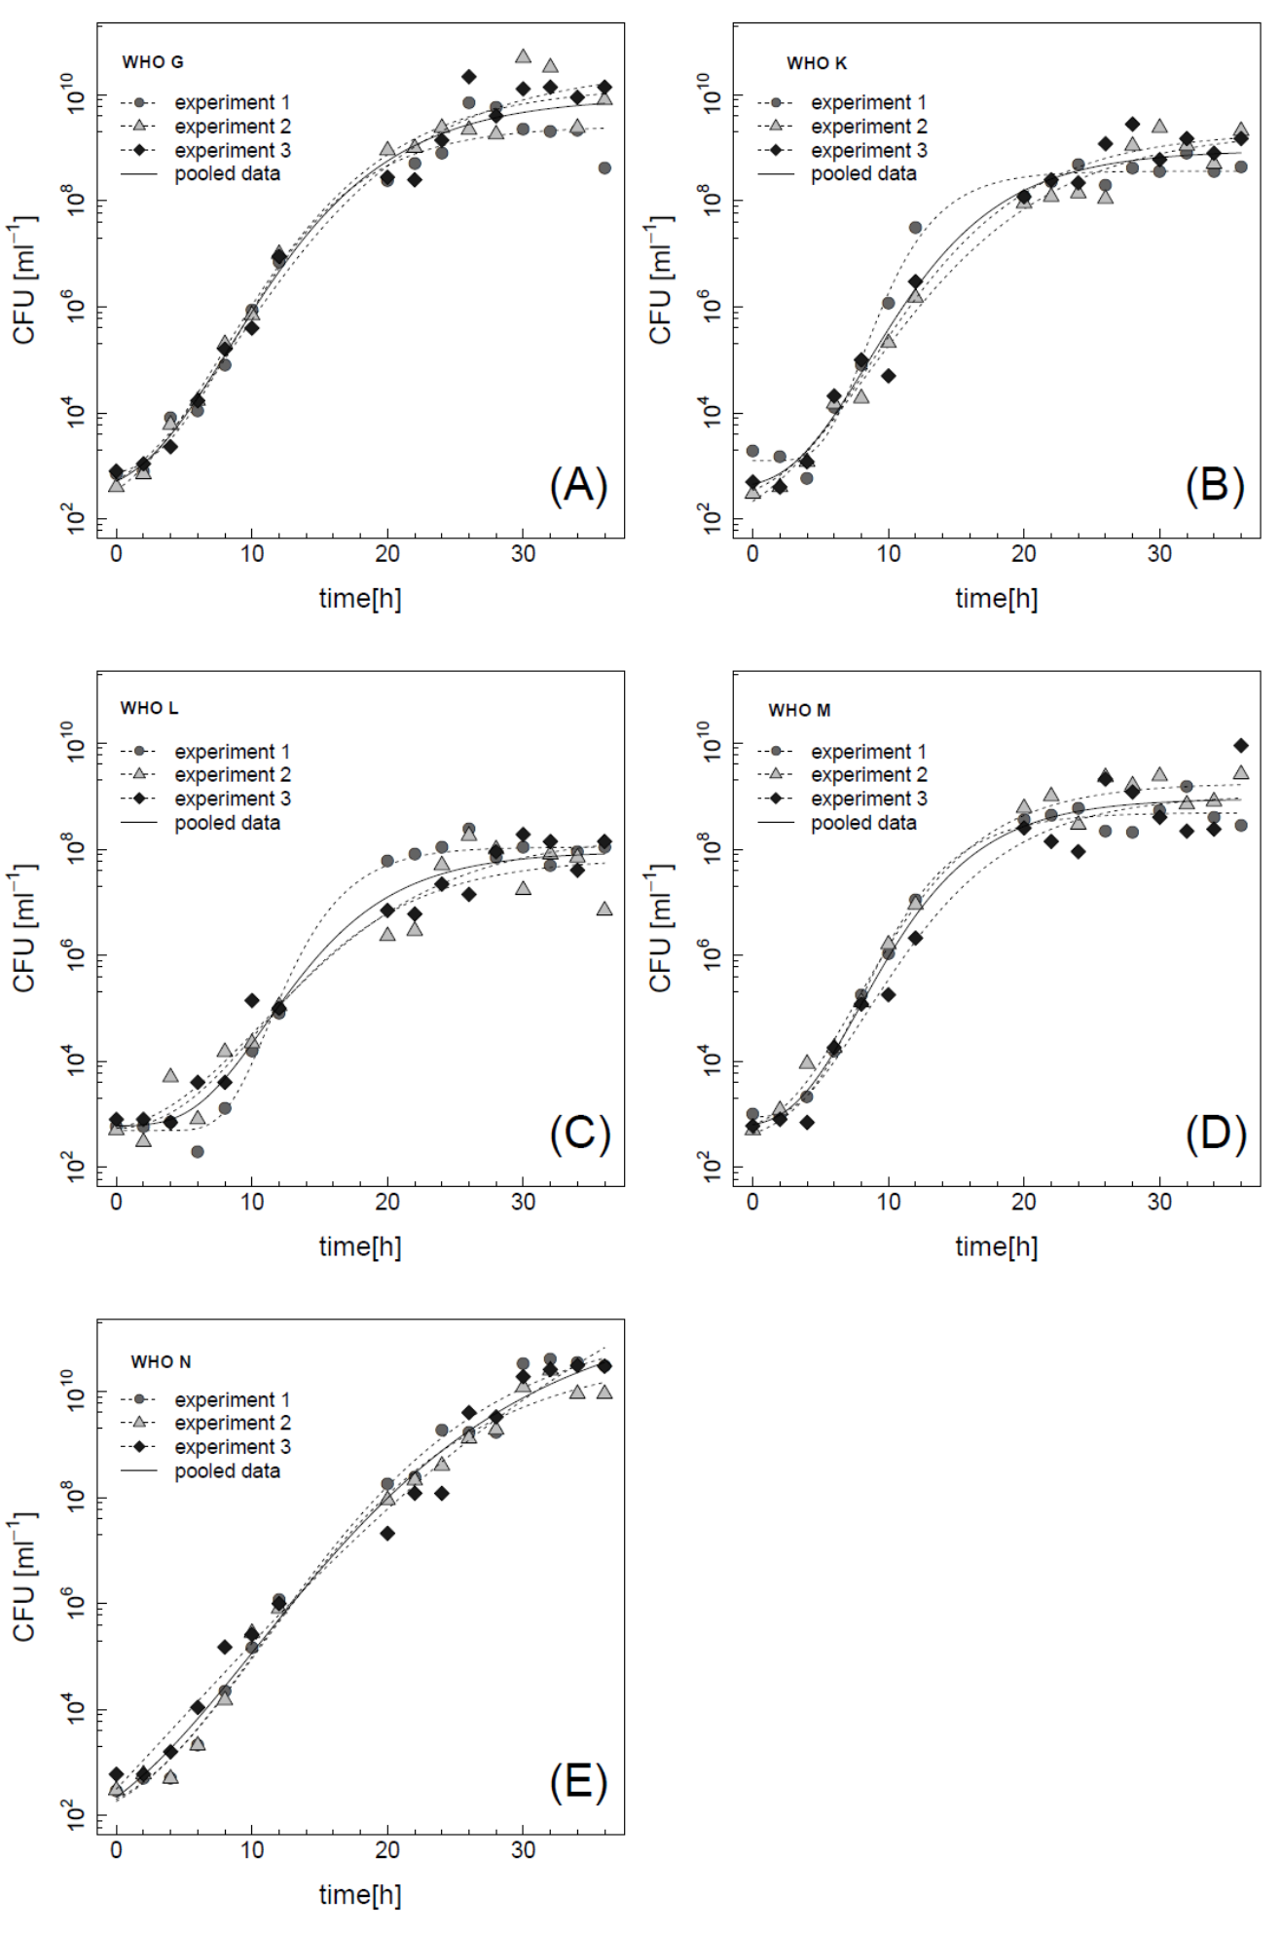

Supplementary Figure 1. Growth curves for five WHO reference strains WHO G (A), WHO K (B), WHO (L), WHO (M), WHO (N). Shown are data from three independent experiments and a gompertz growth model was fit to the data. Data from 36-60 hours were excluded as they show autolysis that cannot be captured with the model, raw data can be downloaded from github https://github.com/sunnivas/PDfunction.

Supplementary Table 1: Parameter estimates from nine different antimicrobials in DOGK18 and model based standard errors.

|  |  |  |  |  |  |  |  |  |  |
| --- | --- | --- | --- | --- | --- | --- | --- | --- | --- |
| Identifier | antibiotics | kappa | kappaerr | upper | uppererr | lower | lowererr | zMIC | zMICerr |
| 22_3_2015_WT_AZ.txt | azithromycin | 2.43 | 0.81 | 0.67 | 0.08 | -2.25 | 0.17 | 0.0267 | 0.0050 |
| 23_3_2015_WT_AZ.txt | azithromycin | 2.64 | 0.60 | 0.60 | 0.06 | -2.07 | 0.11 | 0.0238 | 0.0033 |
| 19_3_2015_WT_CX.txt | cefixime | 2.07 | 0.23 | 0.89 | 0.04 | -0.64 | 0.03 | 0.0001 | 0.0000 |
| 22_3_2015_WT_CX.txt | cefixime | 1.42 | 0.66 | 0.75 | 0.17 | -0.87 | 0.10 | 0.0004 | 0.0001 |
| 19_3_2015_WT_CT.txt | ceftriaxone | 1.69 | 0.21 | 0.70 | 0.05 | -0.74 | 0.03 | 0.0002 | 0.0000 |
| 22_3_2015_WT_CT.txt | ceftriaxone | 1.58 | 0.69 | 0.80 | 0.08 | -0.46 | 0.09 | 0.0004 | 0.0001 |
| 19_3_2015_WT_Chlor.txt | chloramphenicol | 1.54 | 0.28 | 0.85 | 0.03 | -0.12 | 0.04 | 0.3767 | 0.1099 |
| 22_3_2015_WT_Chlor.txt | chloramphenicol | 2.04 | 0.43 | 0.61 | 0.02 | -0.10 | 0.03 | 0.5762 | 0.1461 |
| 19_3_2015_WT_Gen.txt | gentamycin | 0.82 | 0.10 | 0.86 | 0.20 | -206.80 | 397.96 | 0.1522 | 0.3604 |
| 22_3_2015_WT_Gen.txt | gentamycin | 1.17 | 0.28 | 0.96 | 0.19 | -7.96 | 1.60 | 0.2117 | 0.0474 |
| 19_3_2015_WT_Pen.txt | penicillin | 1.19 | 0.29 | 0.77 | 0.15 | -2.06 | 0.18 | 0.0053 | 0.0013 |
| 22_3_2015_WT_Pen.txt | penicillin | 1.01 | 0.19 | 1.05 | 0.11 | -1.15 | 0.09 | 0.0029 | 0.0005 |
| 19_3_2015_WT_Spec.txt | spectinomycin | 2.41 | 0.11 | 0.76 | 0.04 | -10.30 | 0.22 | 5.6452 | 0.2181 |
| 22_3_2015_WT_Spec.txt | spectinomycin | 1.61 | 0.33 | 0.71 | 0.22 | -8.94 | 0.96 | 4.6836 | 1.2304 |
| 19_3_2015_WT_Tet.txt | tetracycline | 1.14 | 0.19 | 0.72 | 0.03 | -0.25 | 0.05 | 0.3259 | 0.0860 |
| 22_3_2015_WT_Tet.txt | tetracycline | 0.90 | 0.17 | 0.83 | 0.04 | -0.13 | 0.07 | 0.7067 | 0.3721 |
| 19_3_2015_WT_CIP.txt | ciprofloxacin | 1.04 | 0.21 | 0.98 | 0.25 | -7.34 | 0.70 | 0.0017 | 0.0005 |
| 22_3_2015_WT_CIP.txt | ciprofloxacin | 1.19 | 0.29 | 0.43 | 0.29 | -10.40 | 1.27 | 0.0018 | 0.0009 |

Supplementary Table 2: Parameter estimates from ciprofloxacin in five WHO reference strains and model based standard errors.

|  |  |  |  |  |  |  |  |  |  |  |  |
| --- | --- | --- | --- | --- | --- | --- | --- | --- | --- | --- | --- |
| Identifier | strains | kappa | kappaerr | upper | uppererr | lower | lowererr | inflection | inflectionerr | zMIC | zMICerr |
| 22_5_2015_WHOG_CIP.txt | WHOG | 0.69 | 0.14 | 0.86 | 0.12 | -2.22 | 0.35 | 0.13 | 0.05 | 0.0327 | 0.0094 |
| 22_5_2015_WHOK_CIP.txt | WHOK | 1.47 | 0.29 | 0.75 | 0.03 | -0.74 | 0.18 | 18.16 | 3.90 | 18.3111 | 3.9561 |
| 22_5_2015_WHOL_CIP.txt | WHOL | 1.56 | 0.27 | 0.89 | 0.06 | -1.02 | 0.10 | 6.92 | 0.85 | 6.3510 | 0.7475 |
| 22_5_2015_WHOM_CIP.txt | WHOM | 3.49 | 0.77 | 0.62 | 0.05 | -1.18 | 0.04 | 0.26 | 0.01 | 0.2122 | 0.0142 |
| 22_5_2015_WHON_CIP.txt | WHON | 1.58 | 0.24 | 0.81 | 0.04 | -0.60 | 0.04 | 1.44 | 0.15 | 1.7405 | 0.1912 |
| 22_3_2015_WT_CIP.txt | DOGK18 | 1.19 | 0.29 | 0.43 | 0.29 | -10.40 | 1.27 | 0.03 | 0.01 | 0.0018 | 0.0009 |